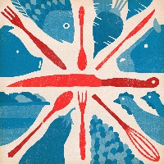
Great British Food Specials @ The Ned Ludd

Dambuster Sausage with sage mashed potatoes, buttered chantey carrots and asparagus. Serves with caramelised onion gravy.
8.50

Cajun style cheeseburger topped with streaky bacon and cider coleslaw served with homemade spiced chips.
9.50

Gammon with chunky chips, fried egg, pineapple and tomato salsa.
10.00

